**REPORT**

**OF**

**MY PERSONAL CDS PROJECT**

**ON**

**DRUG ABUSE**

**AT**

**BAUCHI LGA**

**BY**

**ADEOYE RUTH ADENIKE**

**BA/19A/1221**

**EXECUTIVE SUMMARY**

Adeoye Ruth Adenike, a serving corp member posted to Hospital Management Board, currently serving at Infectious Diseases Hospital, Bayara, Bauchi State with the State code BA/19A/1221 carried out an awareness creation and sensitization programme on Drug Abuse, its consequences, prevention and treatment among young people (a global issue which is becoming a rising event among young people based on the research carried out by United Nation Office of Drugs and Crime (UNODC) during the influencer workshop by MTN Foundation attended by me in Bauchi months ago). The awareness creation and sensitization programme which was done through various medium started on the 3rd of November, 2019 with the media sensitization session which took place every Saturday by 5:30pm to 6:00pm and every Monday by 3:00pm to 4:00pm respectively for the month of November, 2019. Below are the media houses used for the implementation of the media session:

1. Al-barka Radio FM.
2. Bauchi Radio Corporation (BRC)

The school sensitization/talk and interactive session which covers 10 senior secondary schools (7 government schools and 3 private-owned schools) started on the 12th of November, 2019 Barrack, where I sensitized the students and staff of each senior secondary schools with the use of Drug Free World and UNODC Information Education and Communication (IEC) materials.

Names of schools visited for the sensitization outreach:

1. General Hassan Kastinah Unity College.
2. Government Day Comprehensive Secondary School, Bakari Dukku.
3. Dr Ibrahim Tahir Comprehensive Secondary School.
4. Government Day Comprehensive Secondary School Za’adu Zungur.
5. Iqraa Science Academy.
6. Jibril Aminu Secondary School.
7. Havardth International School.
8. Al-Bulshra International.
9. Government Day Comprehensive Secondary School, Shadawanka Barrack.
10. Sky Crest Academy.

The program which had direct impact on not less than 1200 young people and its expected indirect impact on not less than 500 young people had in attendance management staff of the various schools, Dr Simeon Ategbese, a Mental Health Physician of Abubakar Tafawa Balewa University Teaching Hospital, Bauchi State, Dr Pollum Babangida, the Chief Medical Director of Infectious Diseases Hospital, Bayara, Dr Peter Ajanson, a Physician from University of Maiduguri Teaching Hospital, Maiduguri, Publicity and Editorial CDS President, Mr Yunusa Abdulsalam, Young African Leaders Initiative Network (YALINetwork Bauchi hub) representative Miss Kairat Ibrahim Miss Abubakar, Yersmeen Ibrahim Abubakar, and Mr Abiodun Hameed and my efficient team members; Dorcas Ariomerebi, Alimi Uthman Adedolapo, Fedrick Etiosa, David Samuel, Emmanuel Joel, and Olamide Oyeyemi.

***MEDIA SESSION***

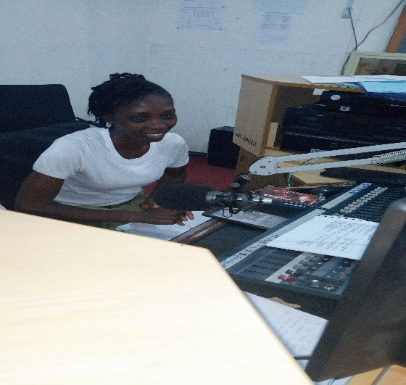***Bauchi Radio Corporation***

***Miss Adeoye Ruth Adenike discussing the treatment categories for different persons at Bauchi Radio Corporation during the third session of the media aspect.***

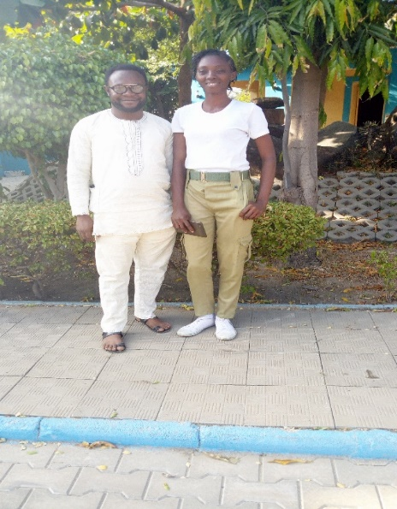

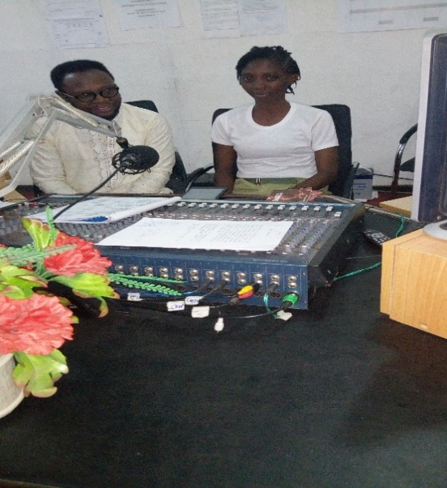

***Dr Ategbese Simeon Olayinka, a Psychiatrist Physician invited by Miss Adeoye Ruth Adenike to facilitate the third session of the media aspect of the project sensitizing the populace at Bauchi Radio Corporation, discussing drug dependence, withdrawal and treatment for drug abusers***

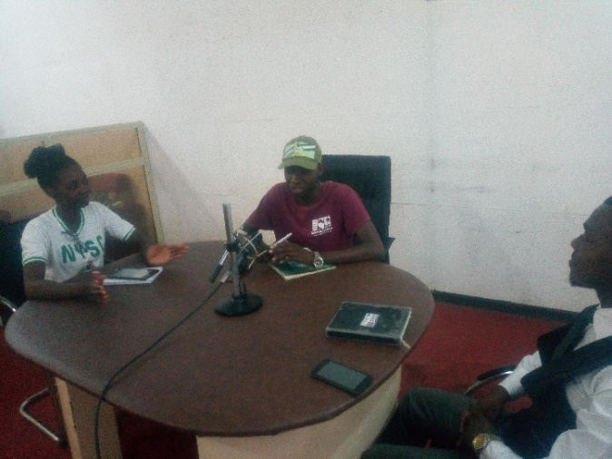

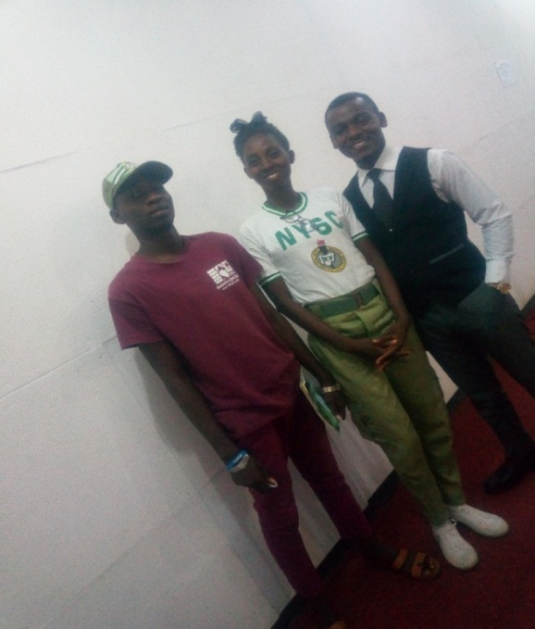

***Miss Adeoye Ruth Adenike with Dr Ajason Peter Sule and Mr Dolapo, the program anchor from Publicity and Editorial Community Development Service after the media sensitization at Bauchi Radio Corporation.***

***AL-BARKA FM RADIO***

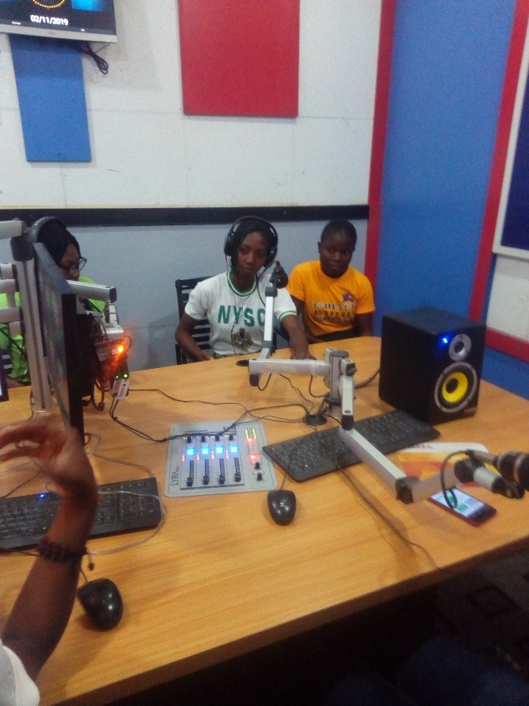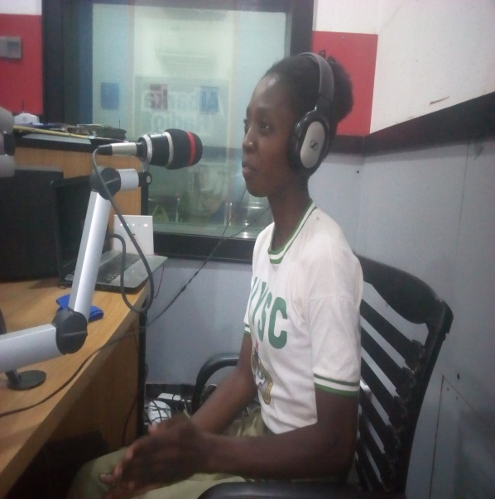

***Miss Adeoye Ruth Adenike facilitating the first session of the media session to sensitize the beautiful people of Bauchi at Albarka Fm with team members. Introducing the program, she discussed in details what drugs are, what it means to abuse drugs, reasons why people abuse drug, categories and examples of commonly abused drugs.***

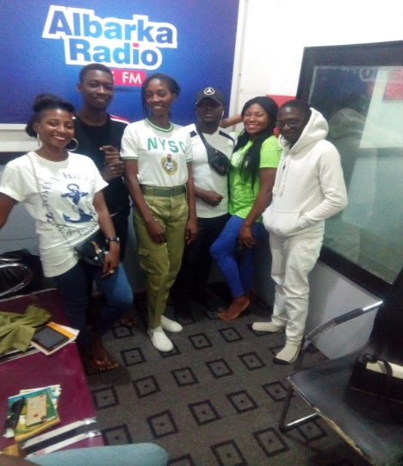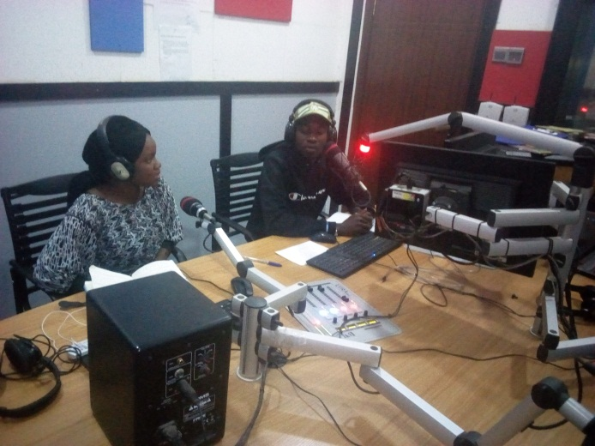

***The above picture shows Miss Adeoye Ruth Adenike and her team members after the media sensitization session at Albarka Radio FM while the second picture shows Dr Babangida Pollum sensitizing the populace on Health consequences of drug abuse.***

***SCHOOL SENSITIZATION***

***General Hassan Kastinal Unity School.***

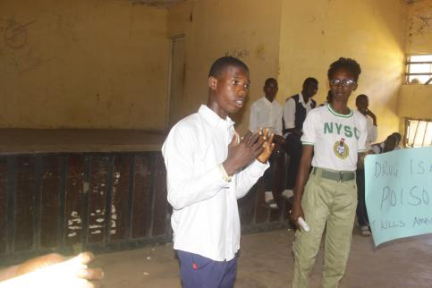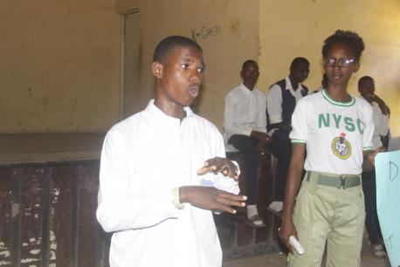

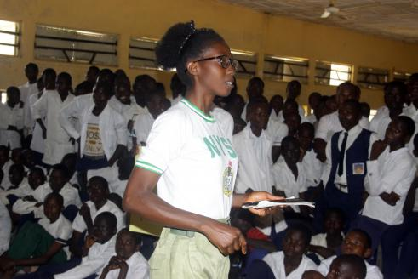***Question and answer session at General Hassan Kastinal Unity School. Miss Adeoye Ruth Adenike satisfactorily answered every questions asked by the participants after the debate session and contributions were also made by the students.***

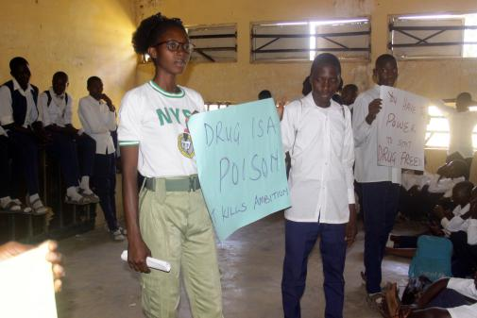

***Miss Adeoye Ruth Adenike facilitating discussion session with the students of General Hassan Kastinal Unity College. Sensitizing the students and staff about the negative consequences of drug abuse as well as the preventive measures.***

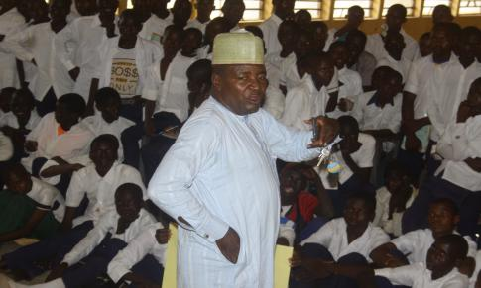***Also, the guidance and counselor,***

***Mr Levi Siman representing the***

***vice principal of the school admonishing***

***the students to desist from abusing drugs and embrace better health.***

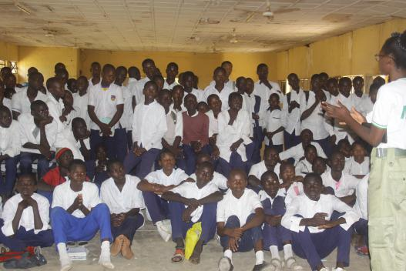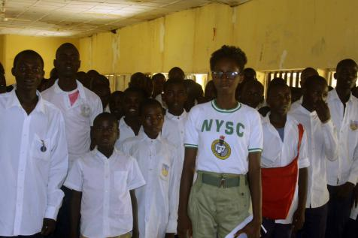

***Cross sectional picture of the participant during opening prayer at General Hassan Kastinal Unity College by Miss Adeoye Ruth Adenike.***

***Government Day Comprehensive Secondary School, Bakari Dukku.***

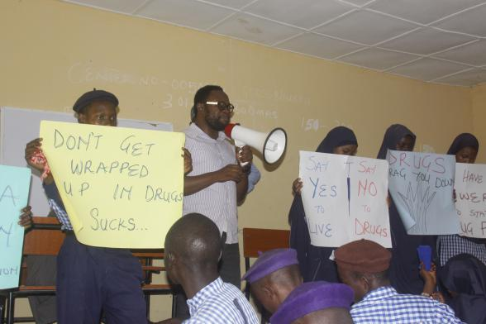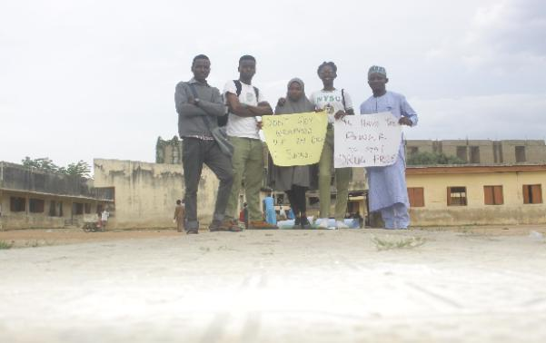

***Team members after sensitization at Dr Simeon Ategbese sensitizing the students of***

***Government Comprehensive Day Government Comprehensive Day Secondary Secondary School, Bakari Dukku. School, Bakari Dukku at the program organized***

***Adeoye Ruth Adeoye***

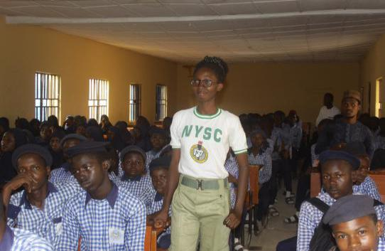

***Miss Adeoye Ruth Adenike monitoring the progress of the program during sensitization by Dr Ategbese Olayinka Simeon at Government Comprehensive Day Secondary School, GCDSS Bakari dukku.***

***.***

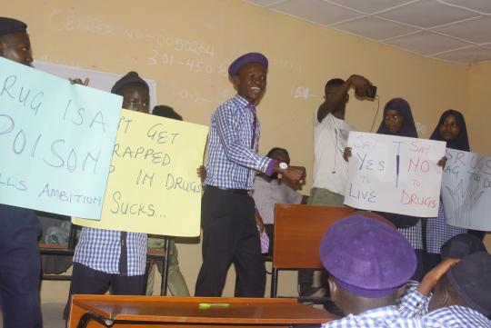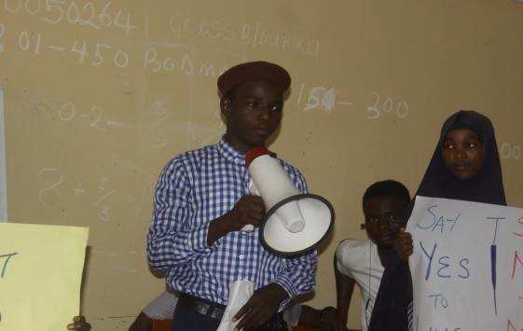

***The studenst discussing on the debate topic “Consequences of drug abuse among young people” during debate session at Government Comprehensive Day Secondary School, GCDSS Bakari dukku.***

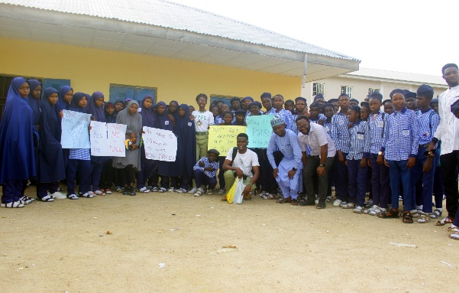

***Group picture with student, staff and team members at Government Comprehensive Day Secondary School, GCDSS Bakari dukku.***

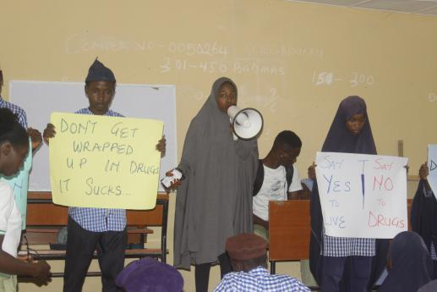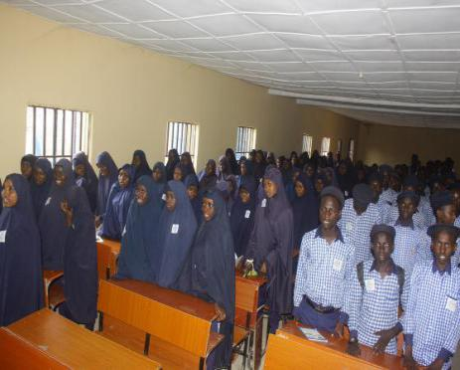

***Yali Representative facilitating the second,Discussion session at Government Comprehensive Day Secondary School.***

***Cross-sectional picture of participants during***

***opening prayer.***

***GCDSS Bakari dukku.***

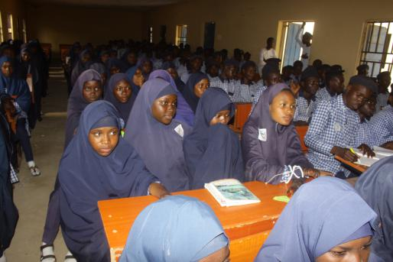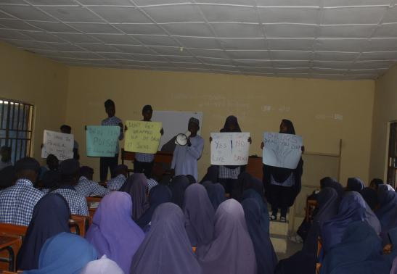

***Publicity and Editorial Community Development Service president facilitating the debate session at Government Comprehensive Day Secondary School, GCDSS Bakari dukku.***

***Dr Ibrahim Tahir Comprehensive school.***

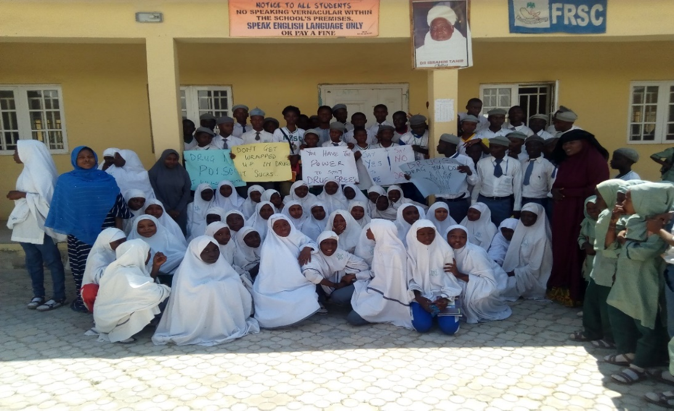

***Cross-sectional picture of all participants of the schhool sensitization at Dr Ibrahim Tahir Comprehensive Secondary School after the program with Miss Adeoye Ruth Adenike.***

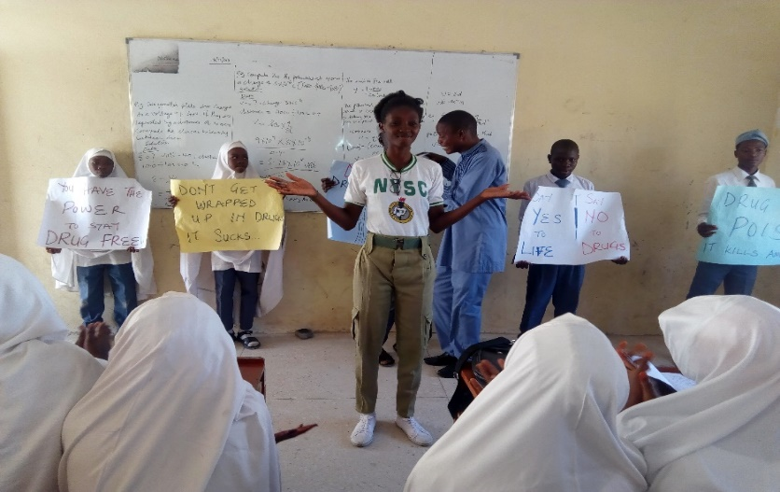

***Miss Adeoye Ruth Adenike satisfactorily answered every questions asked by the participants after the debate session and contributions were also made by the students at Dr Ibrahim Tahir Comprehensive school.***

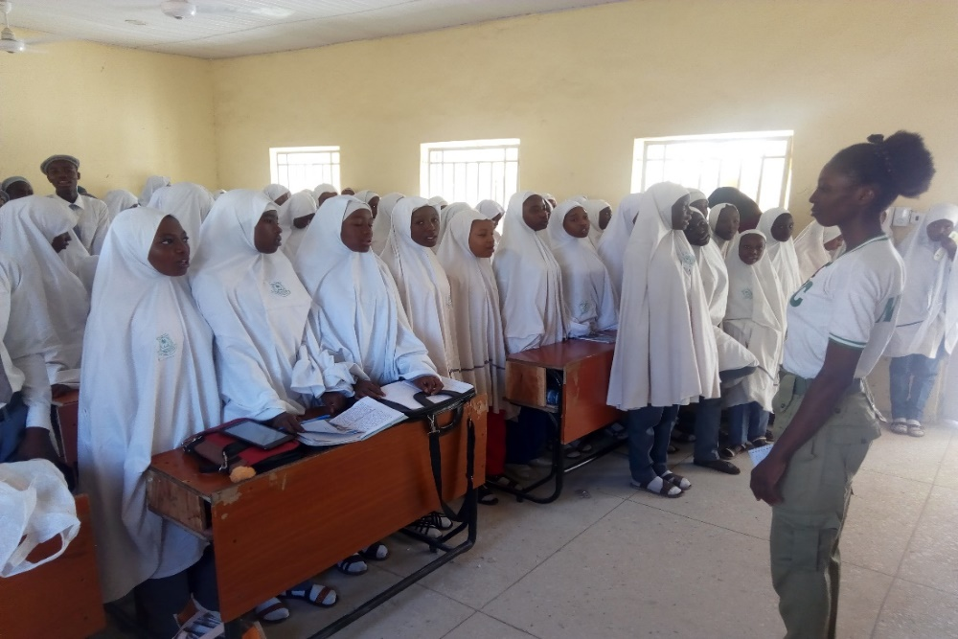

***Cross-sectional picture of the students and Miss Adeoye Ruth Adenike during opening prayer of the school sensitization program at Dr Ibrahim Tahir Comprehensive Secondary School.***

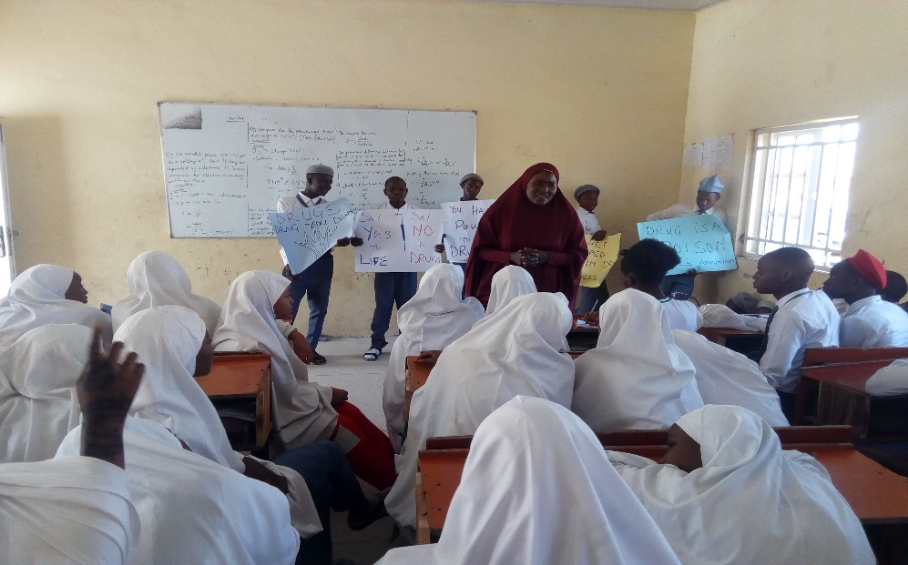

***The guidance and counselor of Dr Tahir Ibrahim Comprehensive Secondary School, admonished the students of the school.***

***Question and answer session at Dr Ibrahim Tahir Comprehensive Secondary School, the facilitators carefully answered each student questions satisfactorily. Doubts were cleared and facts about drugs abuse was clearly stated to the participants thereafter by Miss Adeoye Ruth Adenike and Publicity CDS President, Yunusa Abdulsalam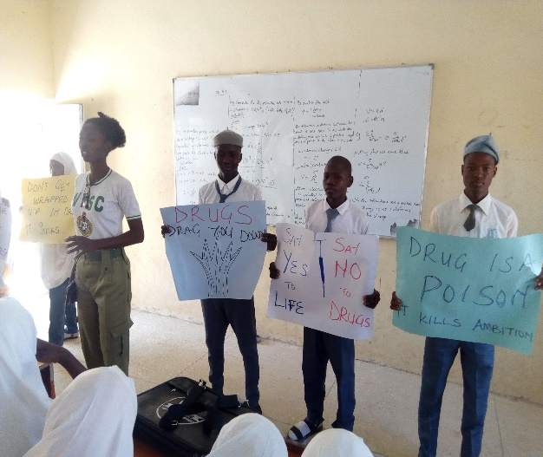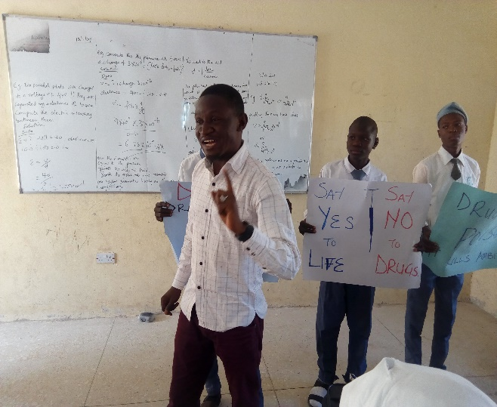.***

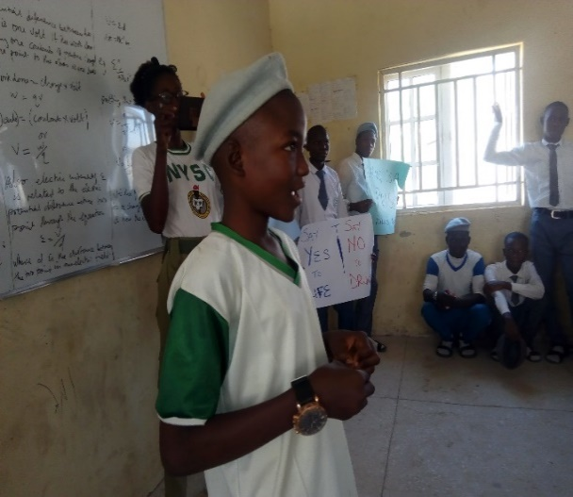***Government Day Secondary School, Sa’adu Zungur***

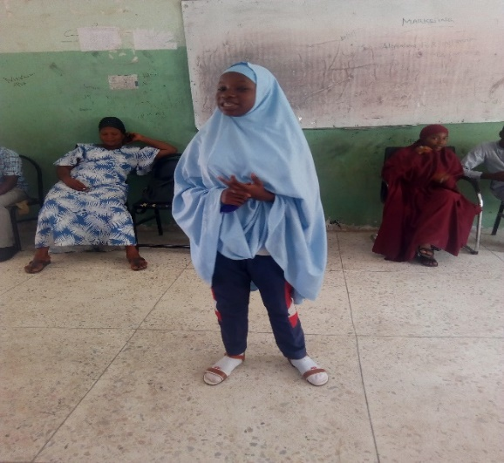

***Debate session at Dr Tahir Ibrahim Comprehensive Secondary School and Government Day Secondary School, Sa’adu Zungur, Bauchi facilitated by Miss Adeoye Ruth Adenike.***

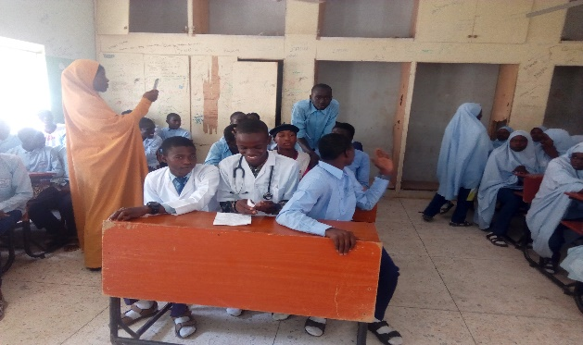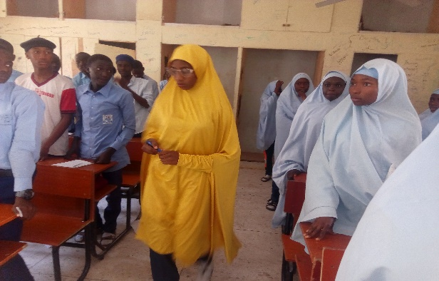

***The guidance and counselor of Government Day Secondary Schools, Sa’adu Zungur, also admonished the student that drugs does no good than harm when abused so, as a promising student, the should not engage in drugs.***

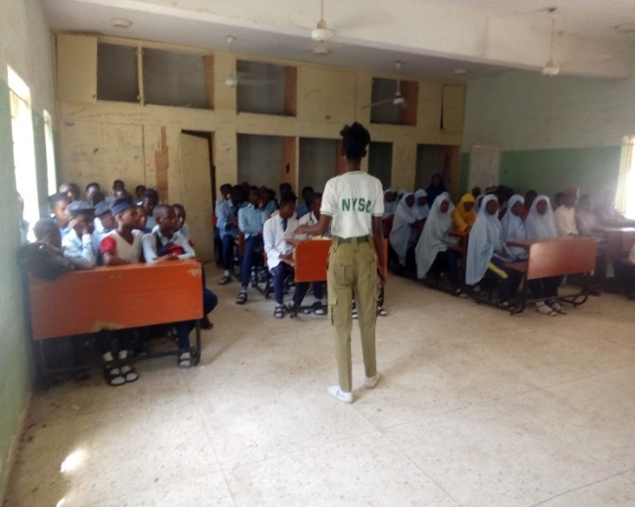***Miss Adeoye Ruth Adenike at Government Day Secondary Schools, Sa’adu Zungur, sensitizing the students on the effects of drug abuse among in-school youth.***

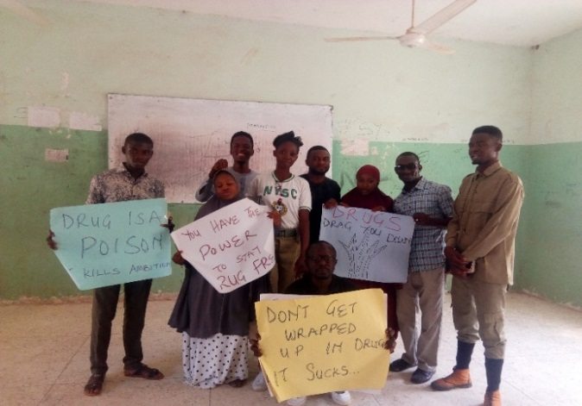

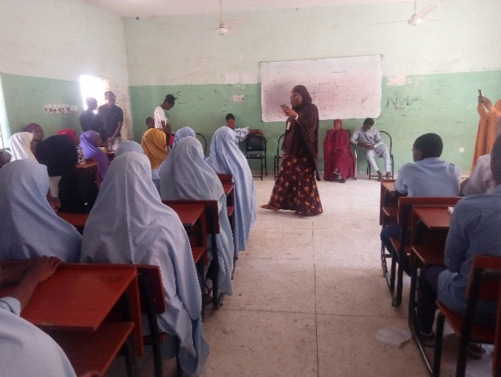

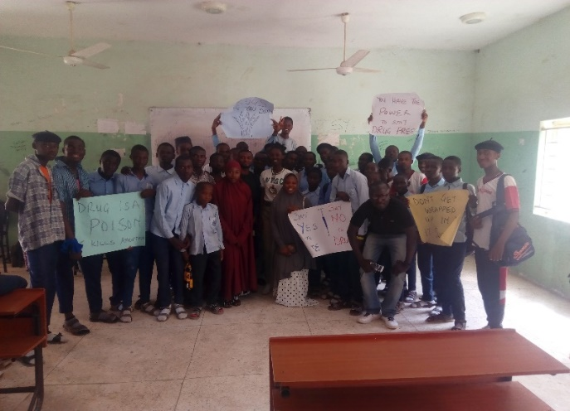***Cross sectional picture showing the female students of the school after sensitization and team members present at the school sensitization at Government Day Secondary Schools, Sa’adu Zungur***

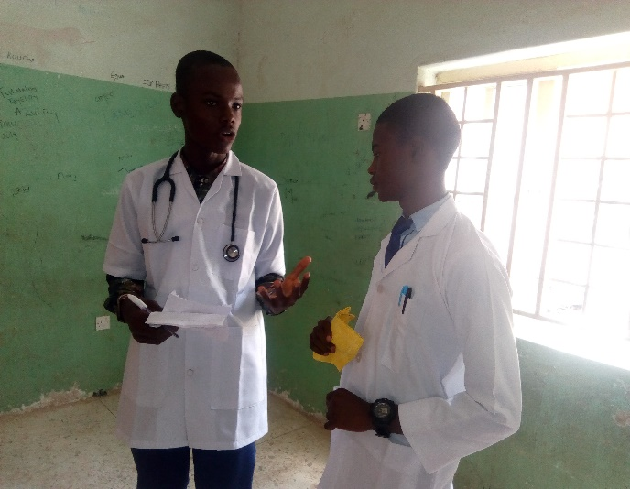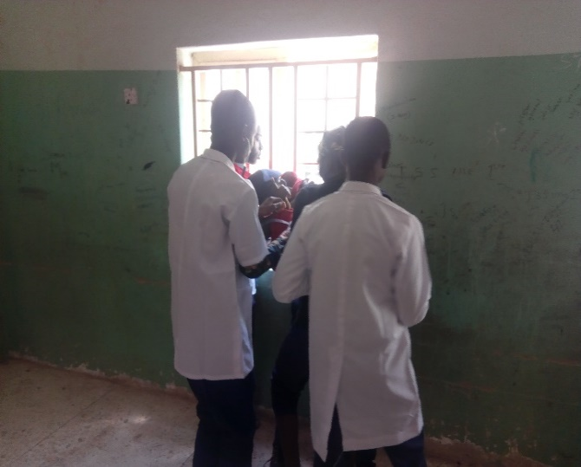

***Drama session by the students of Government Day Secondary Schools, Sa’adu Zungur on “Health consequences of drug abuse among young people.***

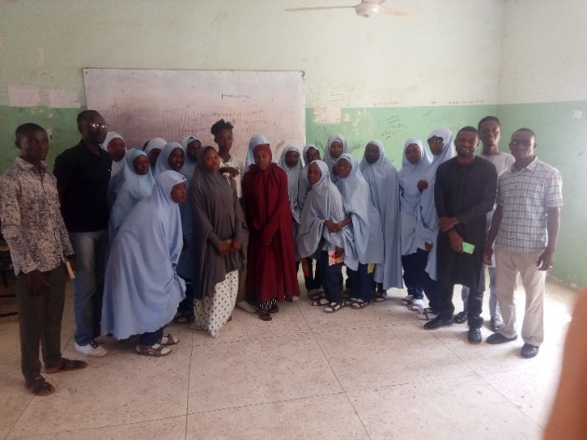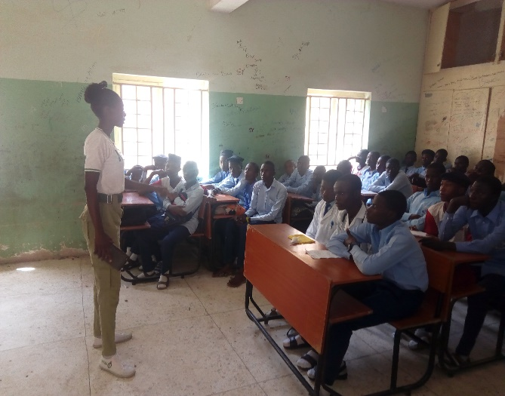

***The vice principal adressing the students of***  ***Government Day Secondary Schools, Sa’adu Zungur.***

***Jibril Laminu Memorial Schools***

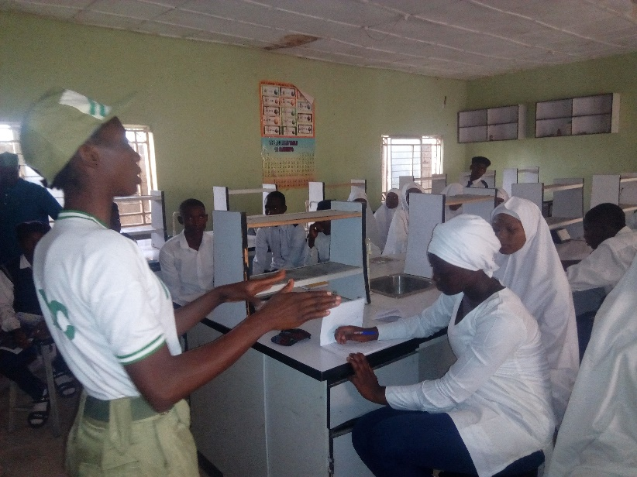***Miss Adeoye Ruth Adenike satisfactorily answered every questions asked by the participants after the debate session and contributions were also made by the students. This signifies the impact made in its little quota by the sensitization program for the day at Jibril Laminu Memorial Schools.***

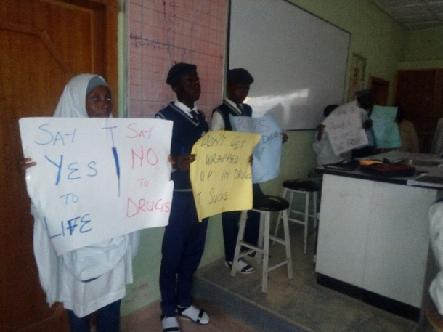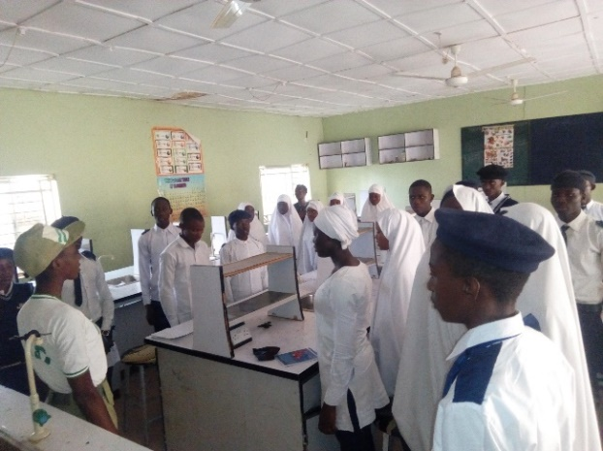

***Cross-sectional picture of the participants during the closing prayer after the powerful and impactful sensitization by Miss Adeoye Ruth Adenike at Jibril Laminu Memorial Schools***

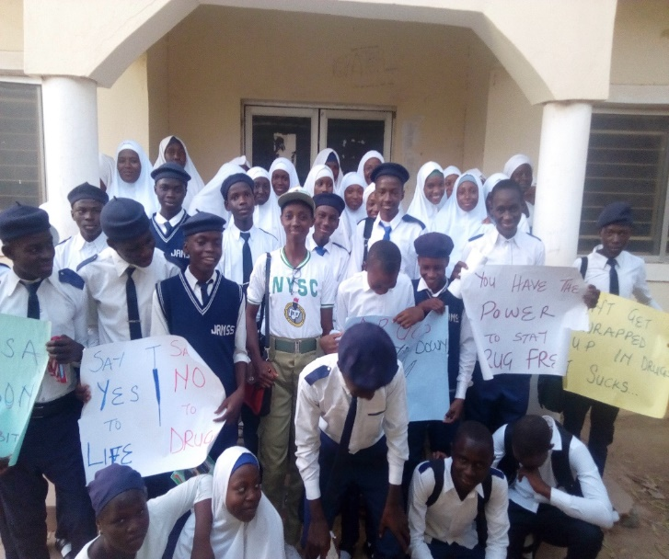***Cross-sectional picture of the participants at Jibril Laminu Memorial College after the sensitization by Miss Adeoye Ruth Adenike.***

***Harvardth International School***

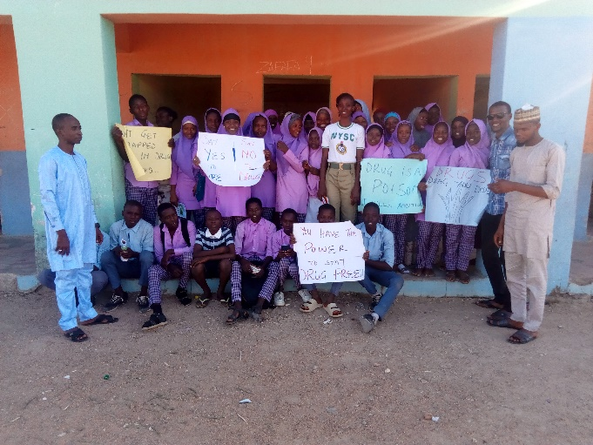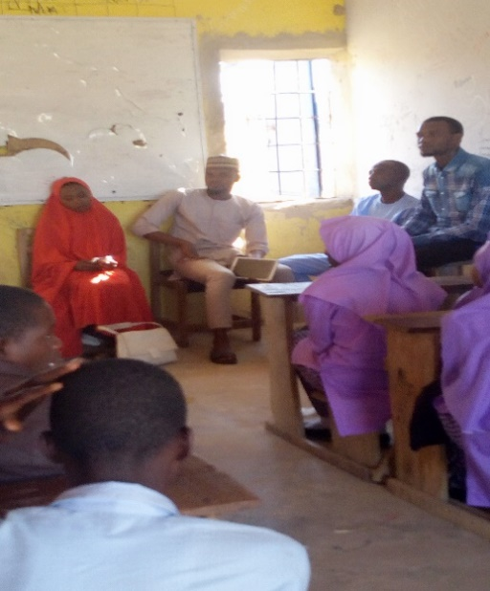

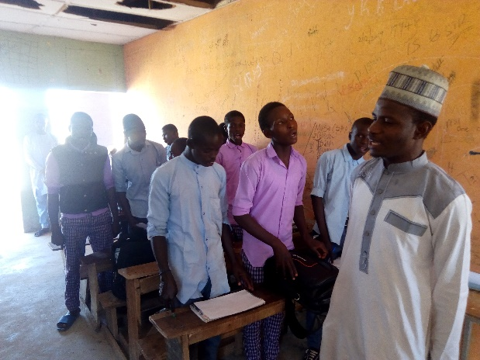***Cross-sectional picture showing the members of staff and students of Harvardth International School, Bauchi during debate session Facilitated by Miss Adeoye Ruth Adenike on the topic “Health consequences of drug abuse” and after the sensitization program.***

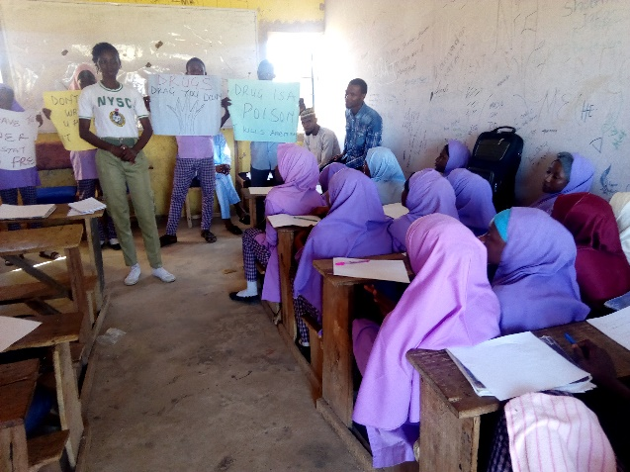

***Cross-sectional picture of the participants during opening prayer at Harvardth International School, Bauchi. After the opening prayer, Miss Adeoye Ruth Adenike did a brief introduction of why she was there to sensitize them on drug abuse giving them facts and figures of the prevalent rate.***

***Iqraa Science Academy***

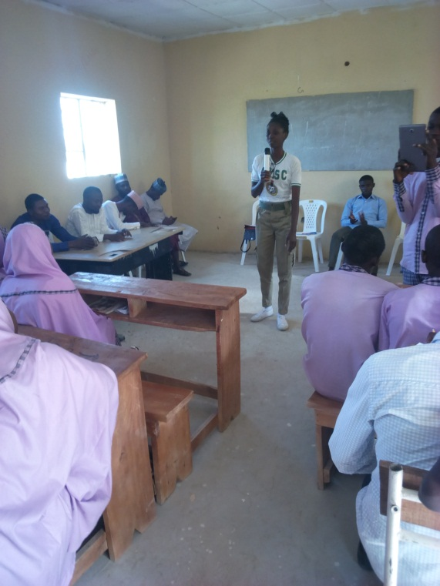 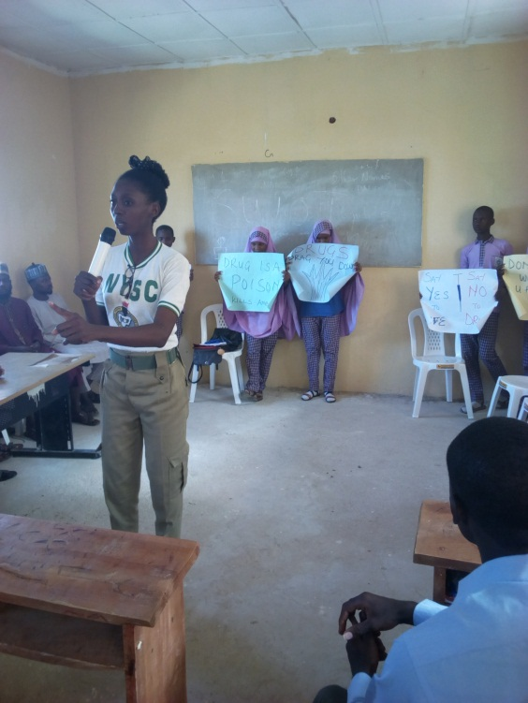

***The picture above shows Miss Adeoye Ruth Adenike sensitizing the students of Iqraa Science Academy.***

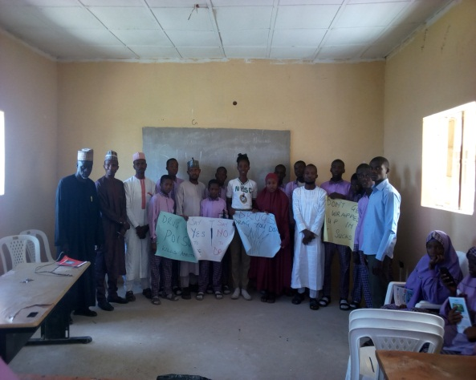 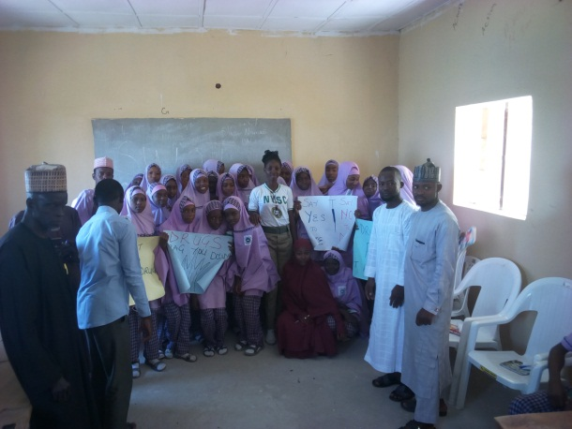

***Cross-sectional picture of the participants at Iqraa Science Academy after the sensitization by Miss Adeoye Ruth Adenike.***

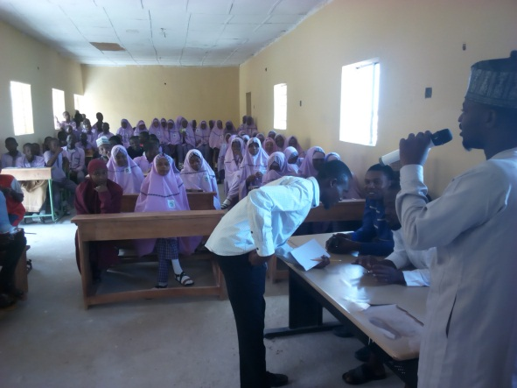 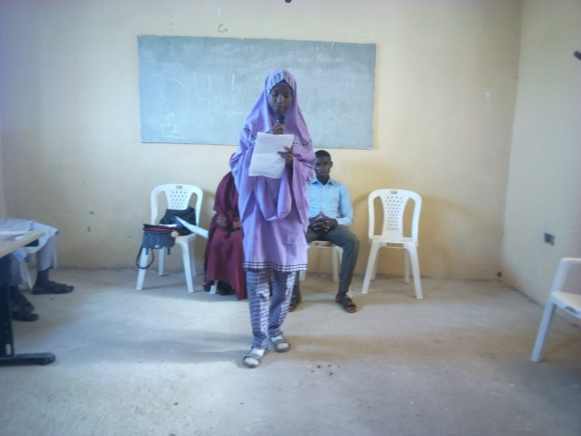

***The picture above shows the student during debate session and member of staff asking question for clarification.***

***Sky Crest International School***

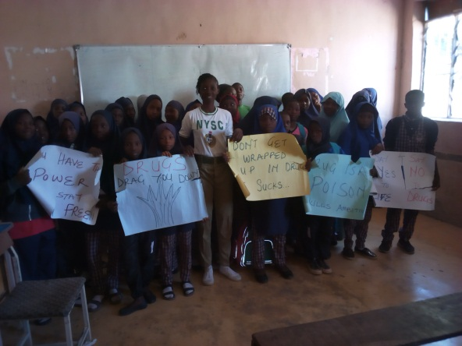 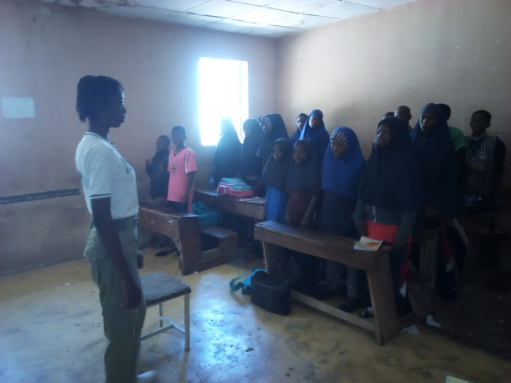

***Cross-sectional picture of the participants after the program and during opening prayer at Sky Crest International School, Bauchi.***

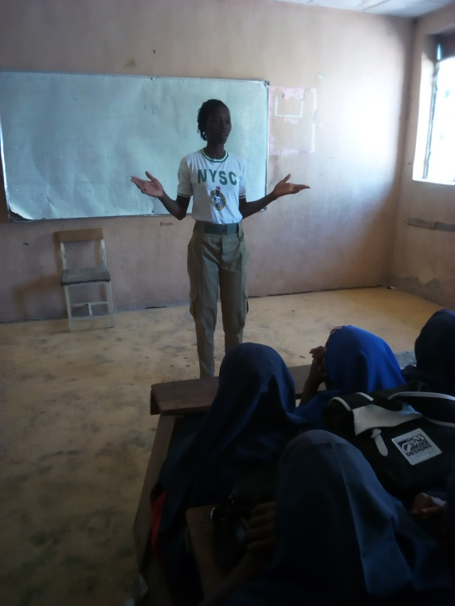 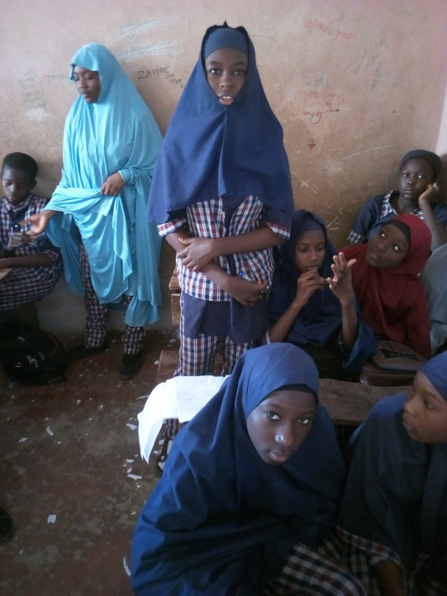

***The above picture shows Miss Adeoye Ruth Adenike during a brief introduction of why she was there to sensitize them on drug abuse giving them facts and figures of the prevalent rate and student asking question after the sensitization.***

***Government Day Secondary School, Shadawanka Barrack.***

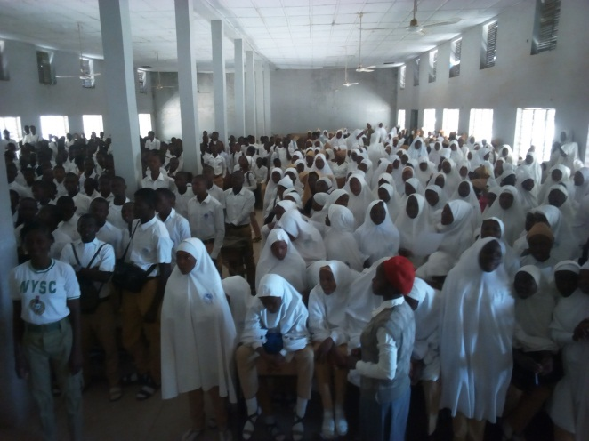 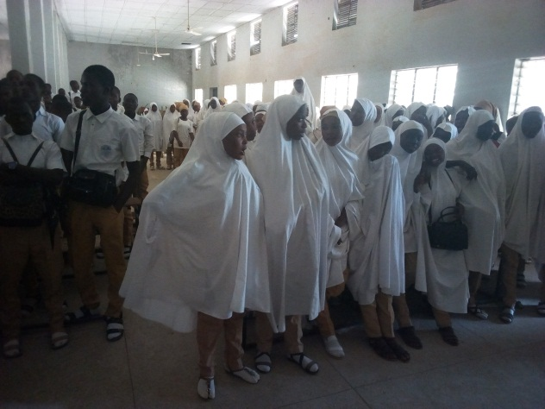

***Cross-sectional picture of the students and Miss Adeoye Ruth Adenike during opening prayer and closing prayer of the school sensitization program at Government Day Secondary School, Shadawanka Barrack.***

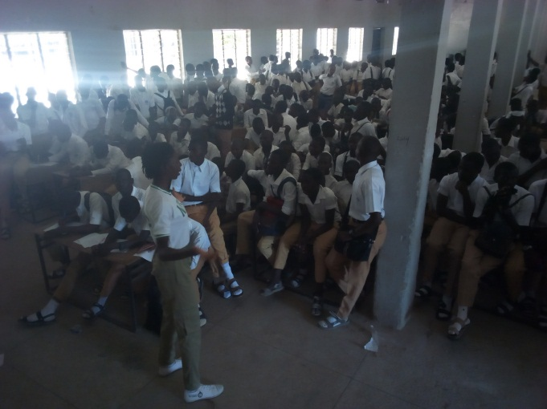 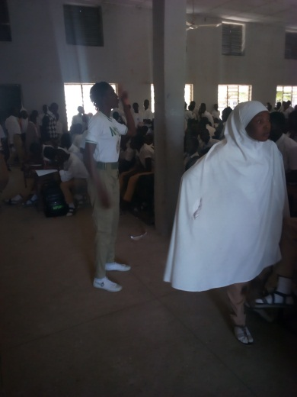

***Corp member Adeoye Ruth Adenike facilitating discussion session with the students of Government Day Secondary School, Shadawanka Barrack. Sensitizing the students about the negative consequences of drug abuse as well as the preventive measures.***

***Al-Bulshra Internaional School.***

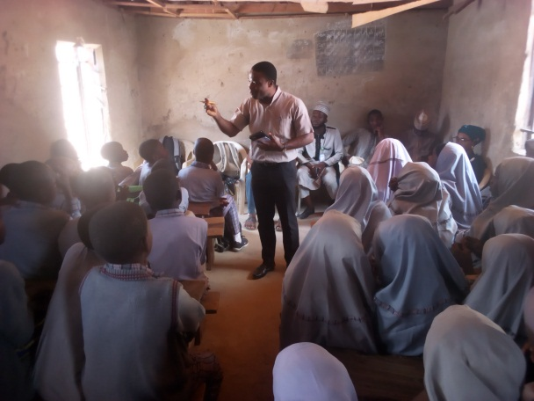 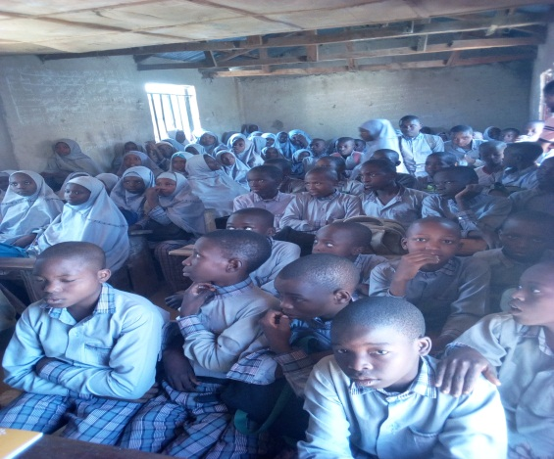

***Mr Joel Emmanuel invited by Miss Adeoye Ruth Adenike at Al-Bulshra International School, sensitizing the students on the effects of drug abuse among in-school youth.***

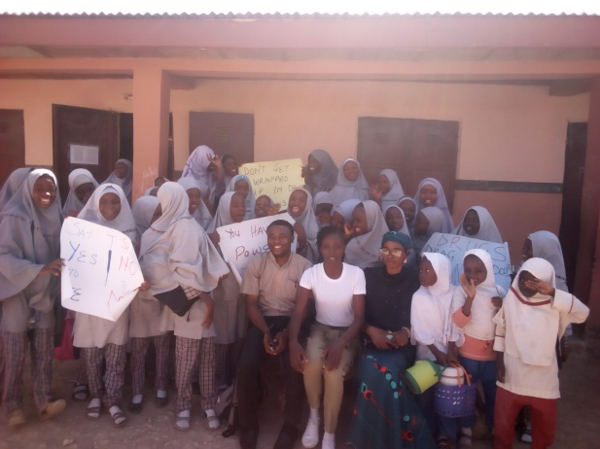 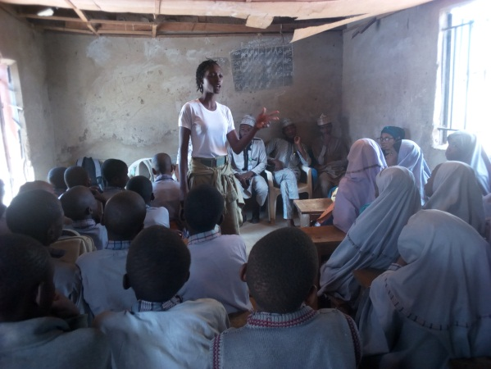

***The picture above shows the students, members of staff and Corp member Adeoye Ruth Adenike during the closing prayer of the school sensitization program at Al-Bulshra International School.***

***GRAND FINALE AT FEDERAL SECRETARIAT CONFERENCE HALL***

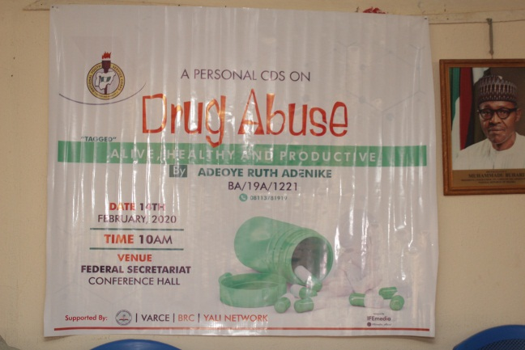 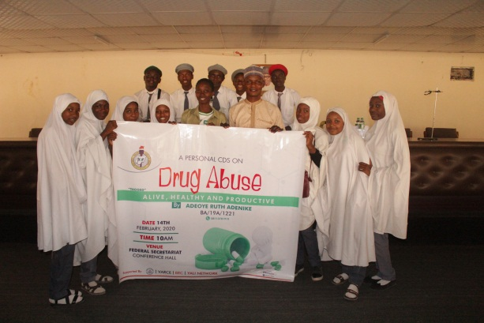

***The above picture shows the program banner, Corp member Adeoye Ruth Adenike and participants from Dr Ibrahim Tahir Comprehensive Secondary School, at the program venue after the program.***

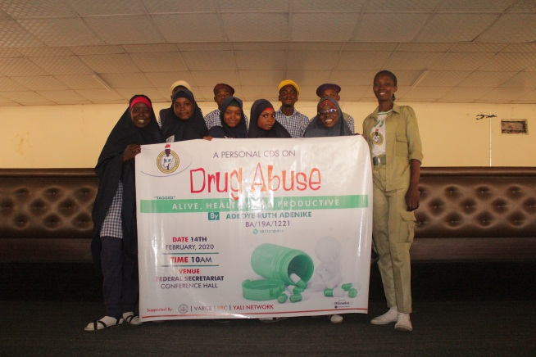 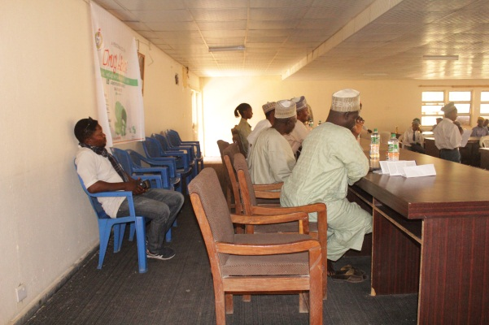

***Cross-sectional picture showing Corp member Adeoye Ruth Adenike with participants from Government Comprehensive Day Secondary Schools, Bakari Dukku and the guests.***

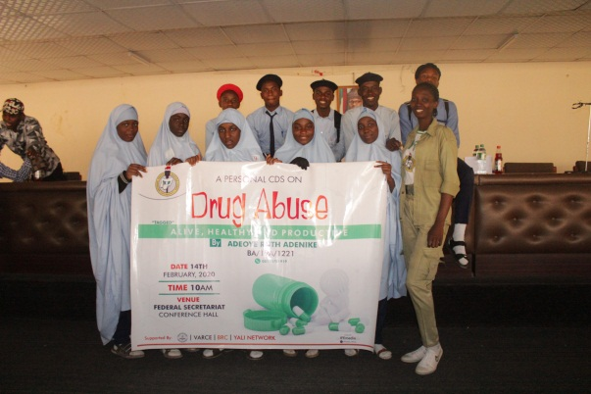 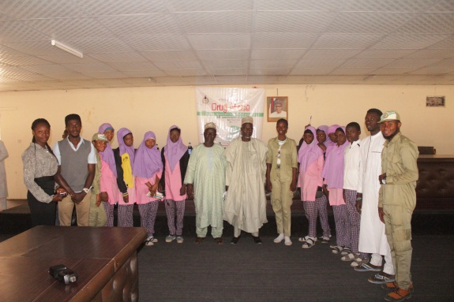

***Cross-sectional pictures show Corp member Adeoye Ruth Adenike with participants from Government Day Secondary Schools,Sa’adu Zungur and Havardth International School.***

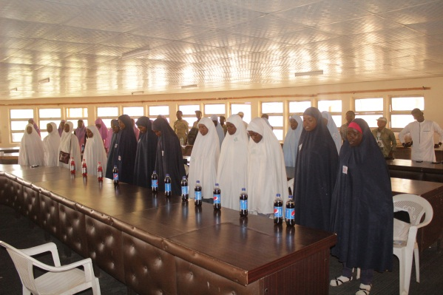 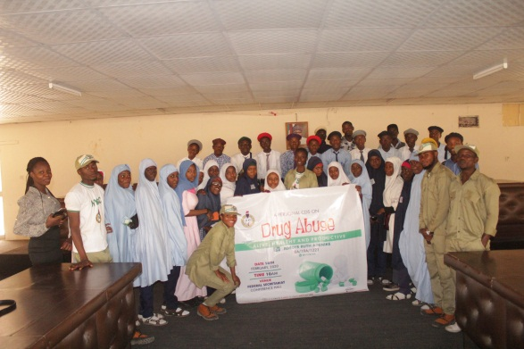

***The above pictures signifies the participants during and after the program.***

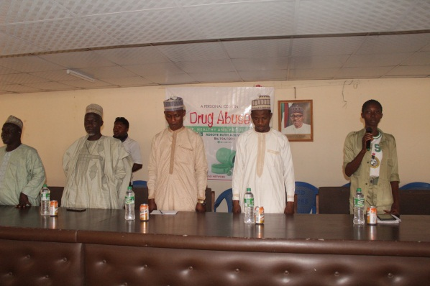 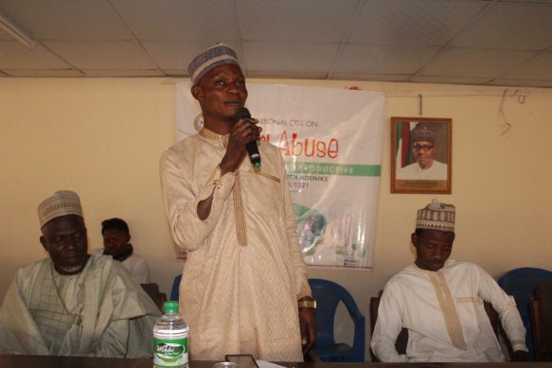

***The above pictures shows Corp member Adeoye Ruth Adenike, Mr Bala Mohammed from Bauchi State Hospital Management board, representing the Executive Director, Dr Ibrahim Waziri the Director of Public Health from Ministry of Health representing the Permanent Secretary, and members of staff of participating schools. Also, Mr Abdul from Dr Ibrahim Tahir SecondarySchool admonishing the students after the sensitization session.***

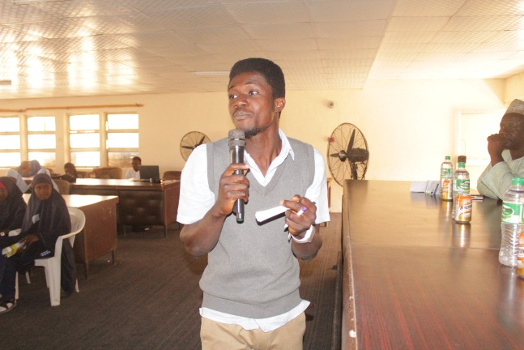 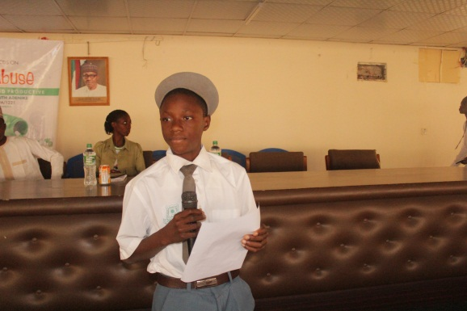

***Cross-sectional pictures showing the first ambassador of the project giving his speech and the effective moderator on duty.***

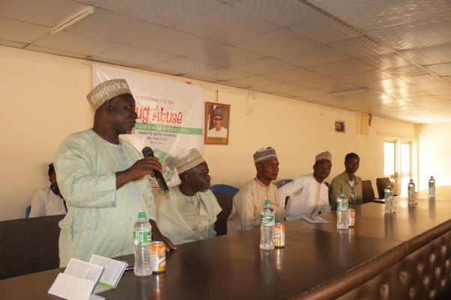 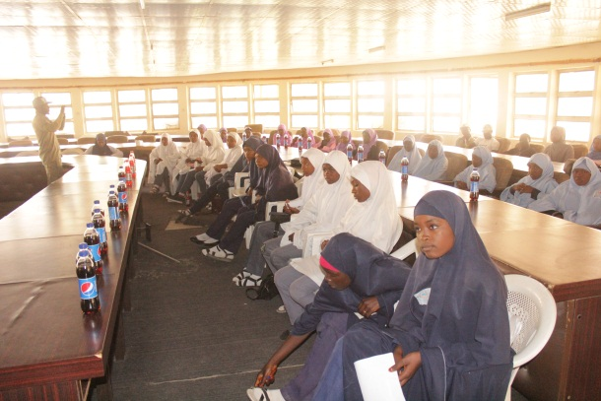

***Cross-sectional pictures showing representative from Bauchi State Hospital Management board contributing to the program of Corp member Adeoye Ruth Adenike.***

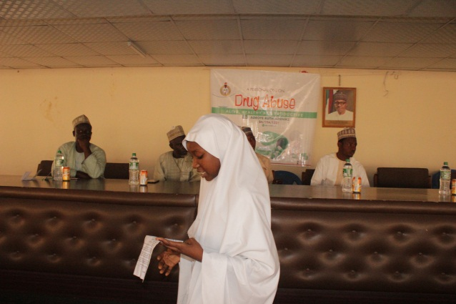 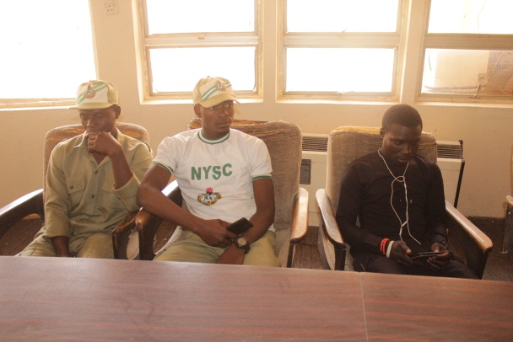

***Cross-sectional pictures showing the second ambassador of the project giving her speech.***

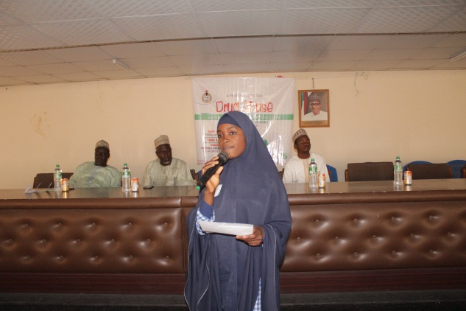 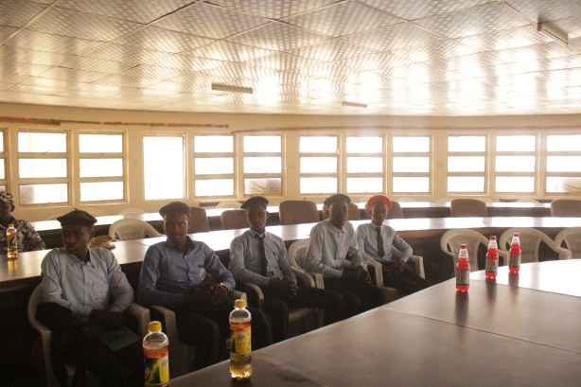

***Cross-sectional pictures showing the third ambassador of the project giving her speech.***

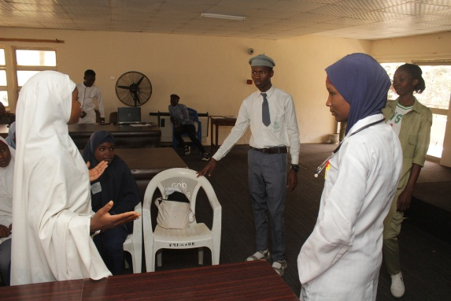 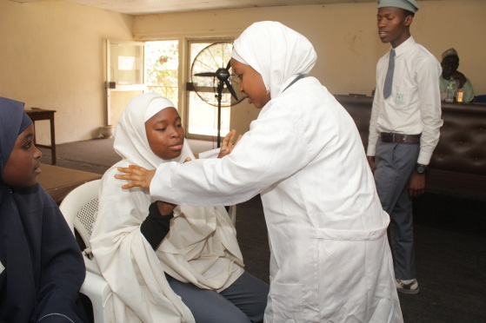

***The above pictures shows the students during the drama session.***

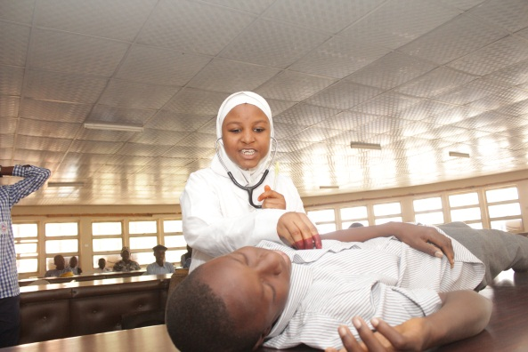 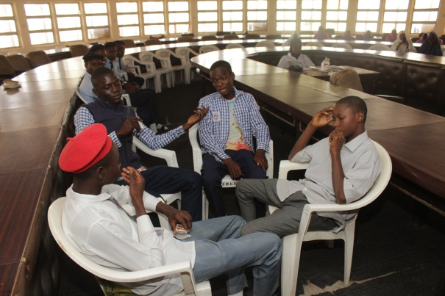

***The above pictures shows the students during the drama session.***

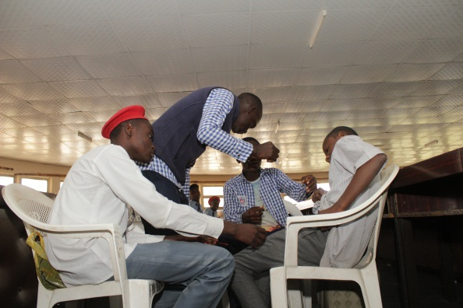 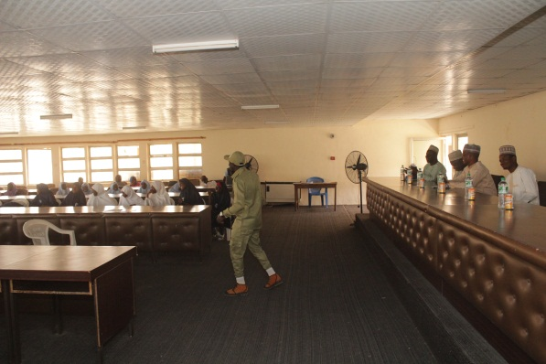

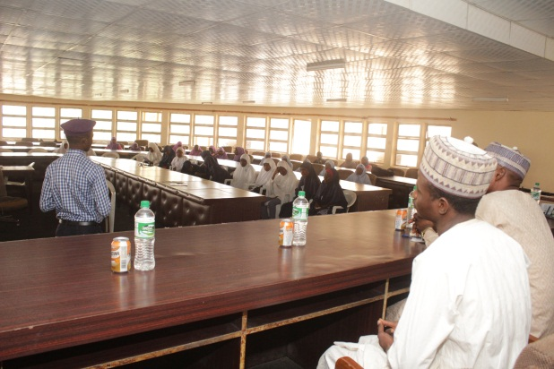 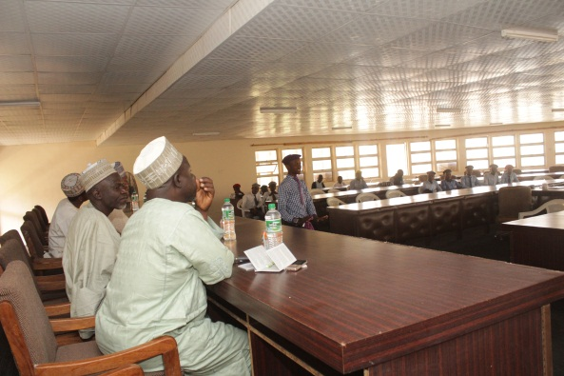

***The above pictures show the students highlighting the lessons learnt so far from the school outreach during the feedback session.***

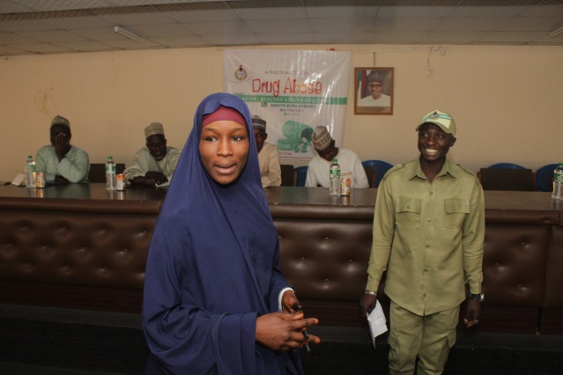 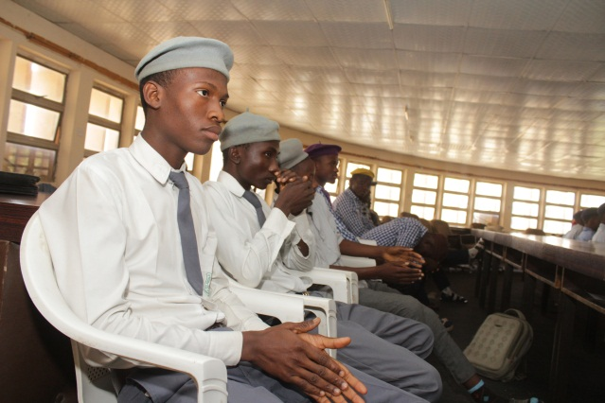

***The above pictures show the students highlighting the lessons learnt so far from the school outreach during the feedback session.***

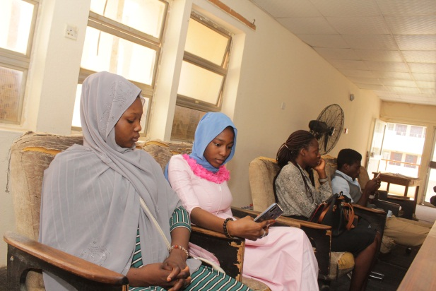 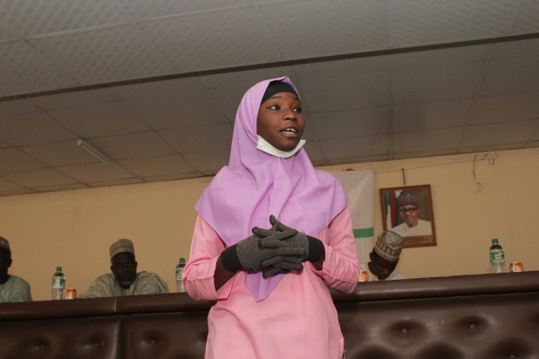

***The above pictures show the representative from Young African Leaders Initiative Network and students highlighting the lessons learnt so far from the school outreach during the feedback session.***

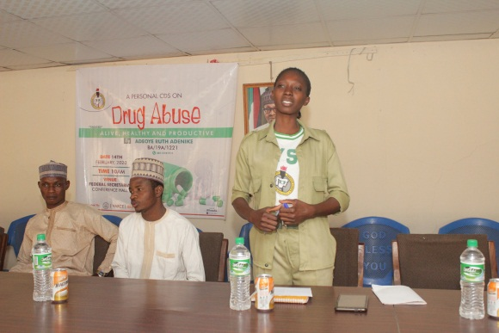 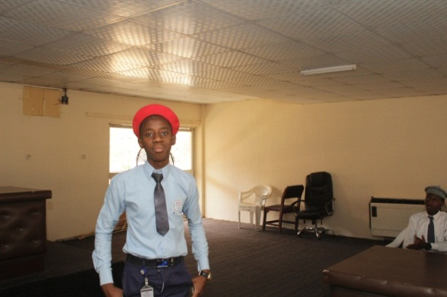

***Corp member Adeoye Ruth Adenike giving the closing remark after the speech.***

**TOTAL INCOME**

|  |  |  |
| --- | --- | --- |
| ***S/N*** | ***NAMES OF DONORS*** | ***AMOUNT DONATED*** |
| 1 | Emmanuel Joel | 2,000 |
| 2 | Ya’u Ado | 500 |
| 3 | Adamu Garba | 500 |
| 4 | Dr Ibrahim Tahir Comprehensive School | 2,000 |
| 5 | Government Comprehensive Day SecondarySchool, Bakari Dukku. | 3,000 |
| 5 | Mr Jay Thomas | 7,000 |
| 6 | Value Reorientation for Community Enhancement (VARCE) | 5,000 |
| 7 | Mrs Oyedele | 5,000 |
| 8 | Ms Asekun-Olarinmoye Temitope | 3,000 |
| 9 | **TOTAL** | **28,000** |

**TOTAL EXPENDITURE**

|  |  |  |  |  |
| --- | --- | --- | --- | --- |
| S/N | ITEMS | QUANTITY | UNIT COST | TOTAL COST |
| 1 | Banner | 1 | 2000 | 2,000 |
| 2 | Gift items for students in each school (a pack of exercise books per school). | 10 | 700 | 7000 |
| 3 | Refreshments for invited guests | 12 | 300 | 3,600 |
| 4 | Placards (cardboards and markers) | 10 | 50 | 500 |
| 5 | Hall charges | 1 | 5,000 | 5,000 |
| 6 | Public Address System | 1 | 500 | 500 |
| 7 | Refreshments for participants | 55 | 120 | 6,600 |
| 8 | Students transport back to school | 10 | 40 | 400 |
| 9 | Total transport charges for sensitization (media and schools). | 4 | 1000 | 4000 |
| 10 | Total printing cost |  | 5000 | 5000 |
|  | **TOTAL** |  |  | 34,600 |

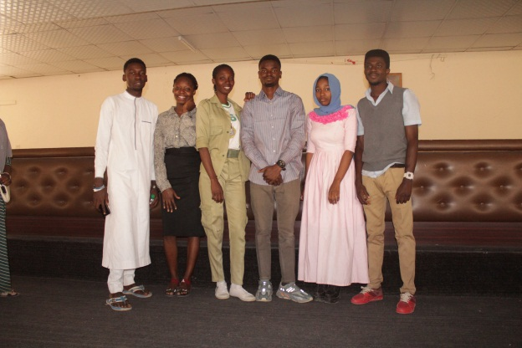

Team